iPhone 11 or higher instructions
1. Open your browser and go to www.silentauctionpro.com  Or point your camera to the QR code below  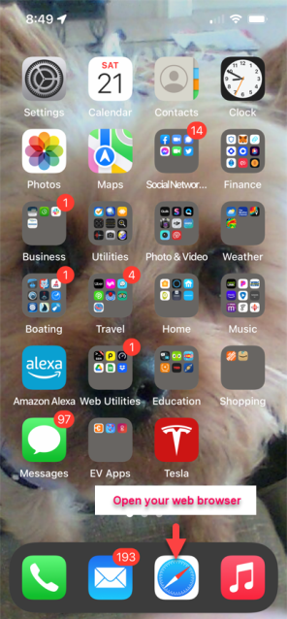 | 2. Once on the webiste, click the export icon at the bottom of the page:  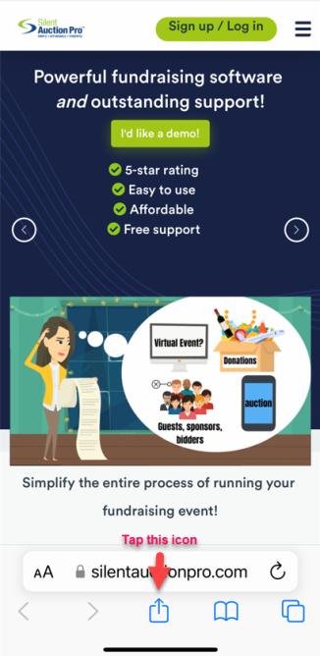
3. Slide up from the bottom to locate the  "Add to Home Screen" and tap:  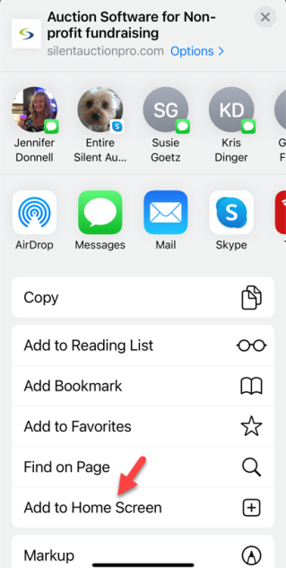 | 4. The short cut to the mobile "app" will be stored on the last page of phone's home screen. You can move it if you wish.  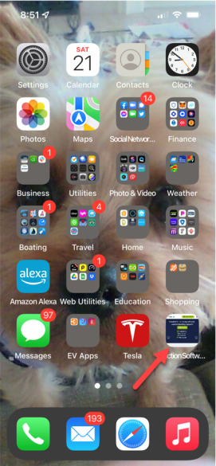

Once you are on the mobile page, enter your group number and tap the Login or Register, or the View Items button.

Android
1. Open your browser and go to www.silentauctionpro.com  Or point your camera to the QR code below  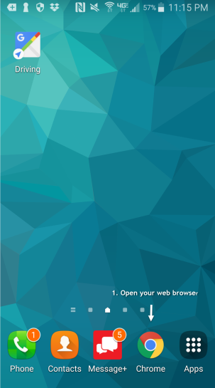 | 2. Once on the mobile page, click the menu icon at the top right corner:  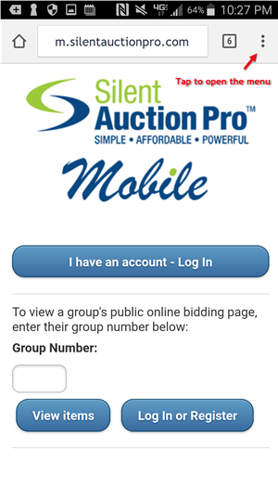
3. Tap the "Add to Home Screen" option:  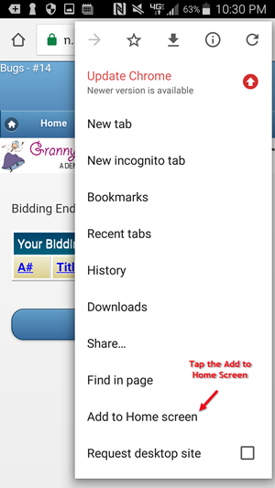 | 4. The short cut to the mobile "app" will be stored on your phone's home screen.  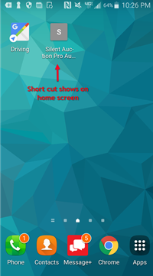
Once you are on the mobile page, enter your group number and tap the Login or Register, or the View Items button.

